cin,cout and endl

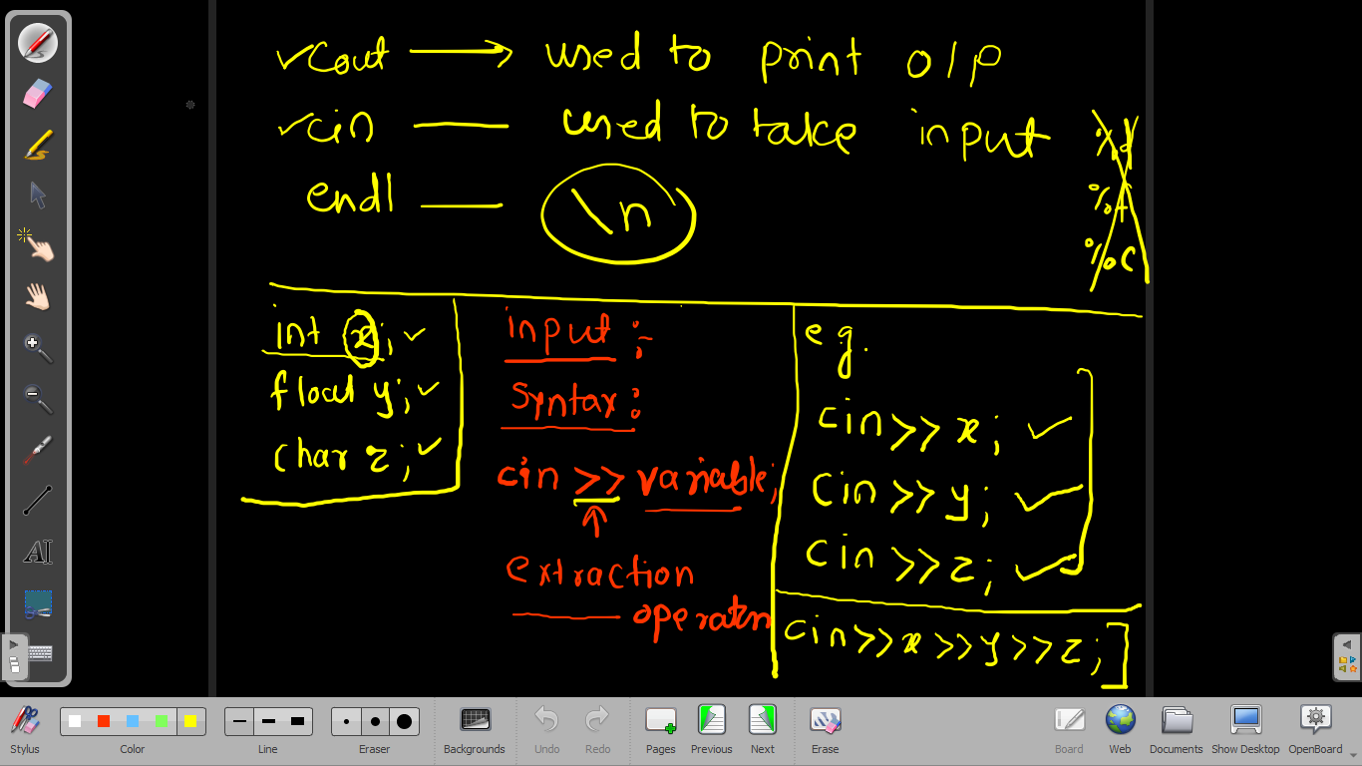

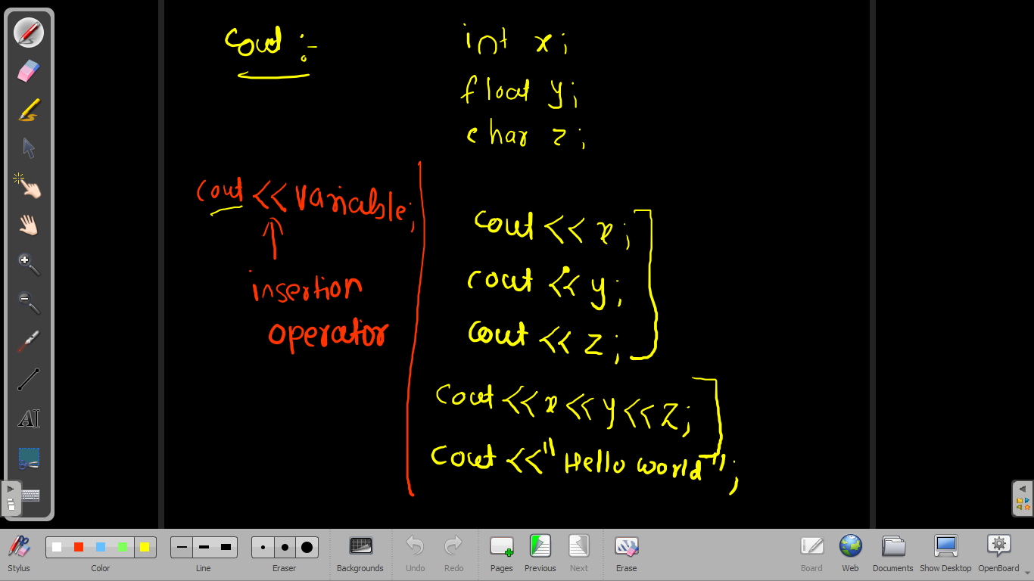

First Program.

#include<iostream>

int main()

{

std::cout<<"Hello World"<<std::endl;

std::cout<<"This is first CPP programs";

return 0;

}

#include<iostream>

using namespace std;

int main()

{

cout<<"Hello World"<<endl;

cout<<"This is first CPP programs";

return 0;

}